Assignment No. 10

Roll No. SC55 - Shreyas Chavhan

===================================================

# Selection Sort Using Template

## Problem Statement -

Write a function template selection sort. Write a program that

inputs, sorts and outputs an integer array and a float array.

## Theory -

Algorithm Selection Sort:

Selection(A, N)

Step 1 − Set MIN to location 0

Step 2 − Search the minimum element in the list

Step 3 − Swap with value at location MIN

Step 4 − Increment MIN to point to next element

Step 5 − Repeat until list is sorted

TEMPLATES -

A template is a simple and yet very powerful tool in C++. The simple idea is to pass data type as a parameter so that we don’t need to write the same code for different data types. For example, a software company may need sort() for different data types. Rather than writing and maintaining the multiple codes, we can write one sort() and pass data type as a parameter.

C++ adds two new keywords to support templates: *‘template’* and *‘typename’*. The second keyword can always be replaced by the keyword ‘class’.

**How templates work?**

Templates are expanded at compile time. This is like macros. The difference is, the compiler does type checking before template expansion. The idea is simple, source code contains only function/class, but compiled code may contain multiple copies of the same function/class.

## Code -

|  |
| --- |
| /****************************************************************  Assignment No. 10 -  Write a function template selection sort. Write a program that  inputs, sorts and outputs an integer array and a float array.  ****************************************************************/  #include <bits/stdc++.h>  using namespace std;  template <class T>  void selection_sort(T arr[], int n){  T temp;  for(int i = 0; i < n; i++){  for(int j = i + 1; j < n; j++){  if(arr[i] > arr[j]){  temp = arr[i];  arr[i] = arr[j];  arr[j] = temp;  }  }  }  for(int i = 0; i < n; i++){  cout << arr[i] << " ";  }  }  int main(){  cout << "Sorting integers: " << endl;  int n;  cout << "Enter size of array: ";  cin >> n;  int int_arr[n];  cout << "Enter array: ";  for(int i = 0; i < n; i++){  cin >> int_arr[i];  }  selection_sort(int_arr, n);  cout << endl;  cout << "Sorting Float numbers: " << endl;  int m;  cout << "Enter size of array: ";  cin >> m;  float float_arr[m];  cout << "Enter array: ";  for(int i = 0; i < m; i++){  cin >> float_arr[i];  }  selection_sort(float_arr, m);  return 0;  } |

Roll No. SC55 - Shreyas Chavhan

===================================================

## Output -

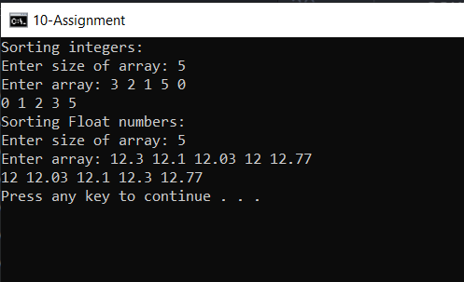

===================================================

Roll No. SC55 - Shreyas Chavhan